A Gift for You
Dear {Recipient},
You are the recipient of a one-year membership to the Honey of the Month Club. You will receive a shipment of pure honey direct from the Land of Milk and Honey every three or four months.

Greeting Line 1
Greeting Line 2
Greeting Line 3
Greeting Line 4
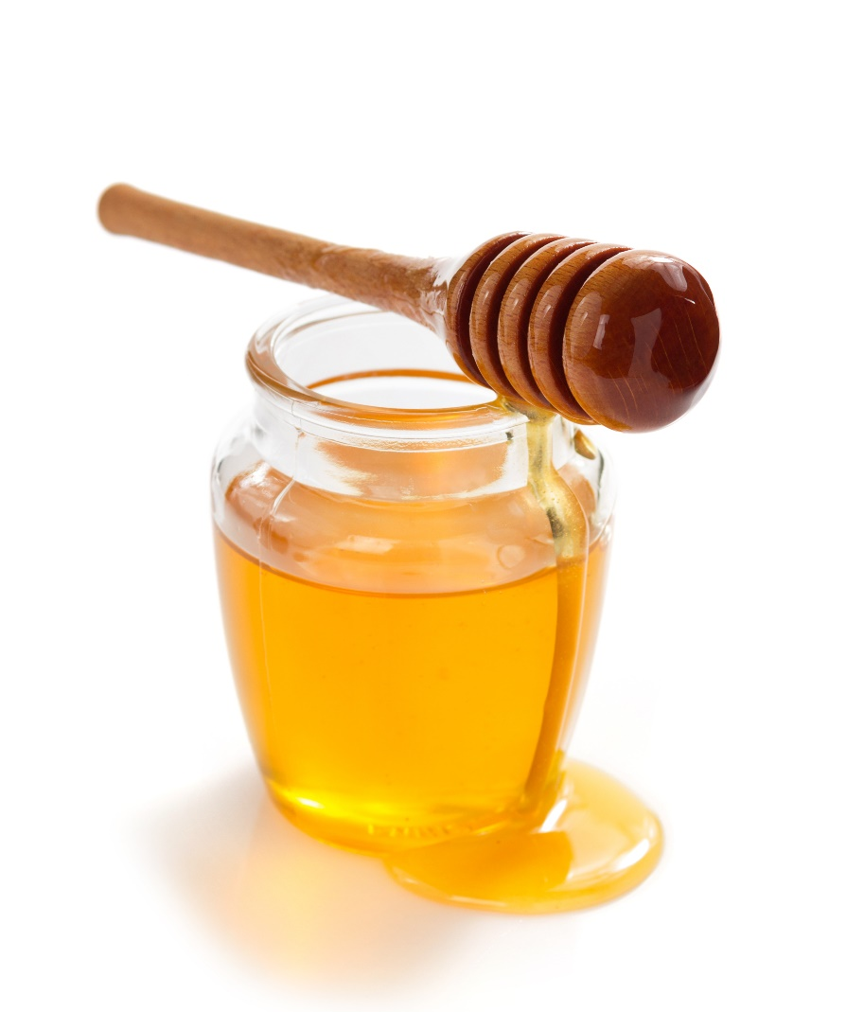
From Line 1
From Line 2

Honey of the Month Club
1-888-688-2582
www.honeyofthemonth.club
honeymaster@honeyofthemonth.club

